**WEEK-3_EF Core 8.0_LAB7**

Lab 7: Writing Queries with LINQ

Scenario: The store wants to filter and sort products for reporting.

Objective: Use Where, Select, OrderBy, and project into DTOs.

Steps:

1. Filter and Sort:

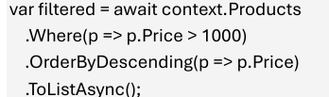

2. Project into DTO:

